NINTENDO CHECKS

1º - USB CHARGER FUSE

Lets check the [fuse](https://imgur.com/jdg3q5I) that lets power from USB C reach the battery chip. Unplug the battery. With a multimeter set to continuity mode, put one probe in one side of the fuse and the other probe in the other side of the fuse. If there is continuity, good, go to step 2, if not you will need to buy that fuse and replace it.

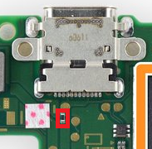

About this fuse.. Looks like an R type - It could be a Matsuo fuse. Their R rated are 0.315a. Which is FAR too low. If you need to replace – I would go for this one or equivalent:

[**https://ro.mouser.com/ProductDetail/Littelfuse/0438035WRA?qs=wd5RIQLrsJi0ppmxLVSh6Q==**](https://ro.mouser.com/ProductDetail/Littelfuse/0438035WRA?qs=wd5RIQLrsJi0ppmxLVSh6Q%3D%3D)

2º - BQ24193

Unplug the battery. On the top of the battery connector, you can see a bit of copper exposed for every cable (5 cables - 2 red/1 grey/2 black. With a multimeter set to DC voltage, you will put the negative probe on one of the blacks and then put the red probe on the first red cable and write down the voltage that the multimeter reads. After that do the same but for the second red cable and write down the value. After that plug the battery back in and, without touching the power button, put the switch charging for 30 minutes. After the 30 minutes, unplug it of the charger, redo everything that I said. If the voltage after 30 minutes is higher than it was, you can assume that your console is charging so the BQ24193 is fine. One less thing to worry about, go to step 3. If it didn't charge at all, probably your BQ24193 is dead.

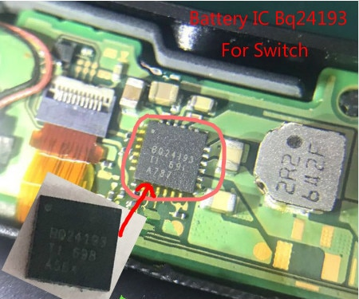

After step 2, and everything is fine, just leave it charging for more than 1 hour, after that 1 hour, try power it on and if nothing appears on the screen, hold the power button for 15 seconds, release it and press back on it. Still nothing? Go to step 3

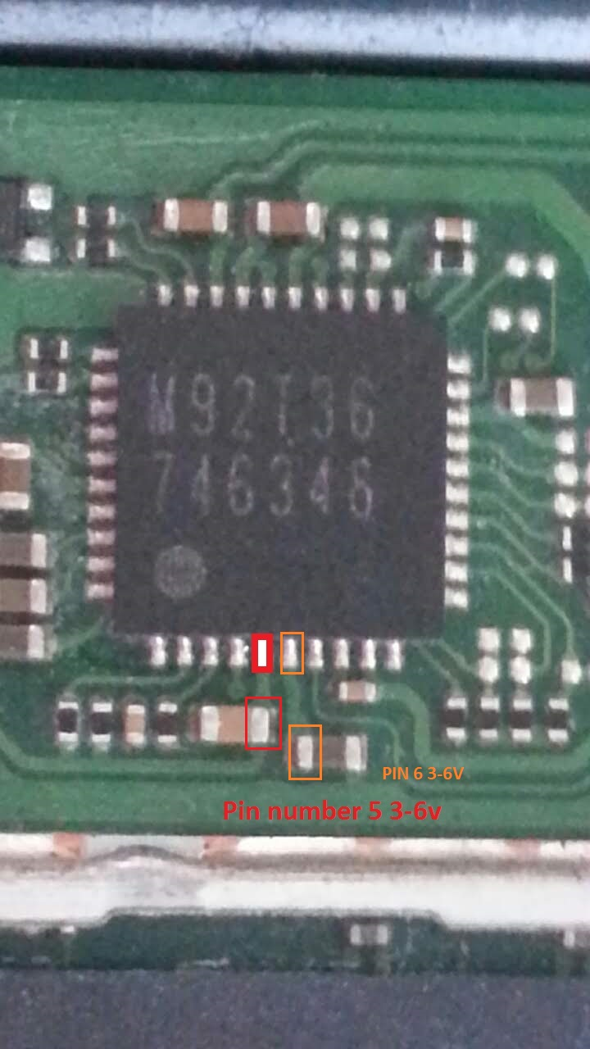3º - Now that you know that your switch is charging, you need to check for shorts. Unplug the battery, remove every thing that is on top of the motherboard(ribbon cables, aux board, cpu cooler and fan, etc. just dont remove the eMMC chip because is a pain in the \*ss to take it out) and with a multimeter set to continuity mode, put the black probe on a good ground(the big metal shield to the left side of the battery or the metal part of the usb c port) and with the red probe check every capacitor(little brown things). It's suppose to have continuity in one of the sides of the capacitor, continuity in both sides of the capacitor means short to ground. Check the M92T36 pins for shorts too(Its suppose to have like 3 shorts to ground on that chip). After checking the front side of the main board, remove it out of the switch and check in the back for shorts to ground. There is an area full of capacitor, right behind the CPU, if one of those capacitors is shorted, the switch is trashed. If you found one or more shorts around a chip, 2 options, or the capacitor is bad, remove it and test to see if the short still there. If so, most likely the chip that is by is side is bad and you need to replace it. Or you remove the capacitor and the short disappear, then you need to replace that capacitor. No short? That's nice, go to step 4.

4º - Ok. Now you know that you don't have shorts. Let’s check the [M92T36](https://imgur.com/a/jiqZZAu" \t "_blank). And now is the risky stuff. You will need a multimeter with at least one probe with a very fine tip. If the probes of your multimeter are normal, you can always solder a paper pin to the red probe). Put the main board back in the switch frame, you don’t need to connect anything, just connect the battery. After connecting the battery, click on the power button, put the multimeter to DC Voltage and then put the black probe to a ground and with the red probe touch the pin 5 of M92T36(check the link above, if you are afraid of touching that pin, as you can see in the image, if you follow the trace of pin 5, ends up in a capacitor, you can check there since it’s easier to touch with a probe). In that pin you are supposed to have 3v to 6v. If you have 0v or less, you have a short on that line, since pin 5 is an input line, the short comes back from that line. Now you need to check the output voltage that is pin 6, with the black probe on ground and with the red probe touch the pin 6 or the capacitor on the end of the trace(again, check image above) and its suppose to have between 3v to 6v. 0v in pin 6 means M92T36 is bad. If values are correct, go to step 5

5º - Visually, inspect the screen ribbon cable and the backlight ribbon cable. Check both connectors on the board. If nothing looks wrong, go to step 6.

6º - The console is most likely turning on, is not showing anything. If you know that your console is in version 7.x.x, sorry but for now the only thing that you can do is leave it charging all night and trying to put it to recovery mode and leave it there for 2 hours or more. If you don't know the version or is below 7.x.x, you can put it in RCM mode and try to inject hekate latest payload. There is a lot of tutorials online on how you can put your console into RCM mode and how you can inject payloads. If the screen turns right on with hekate payload, your console is fine, the firmware is not, and from there you will have to follow a lot of things that I can explain to you later on. If even the payload method failed, you probably will have a PI3USB30532 bad or the CPU is just dead af.

So, with the board upside down you'll see just above the USB C connector is a rectangular chip - this is PI3USB30532, a "6:4 differential channel bi-directional matrix switch solution for switching USB3.0 and/or DP1.2 signals through USB3.0 Type-C connector"

**Applications**

* Routing USB3.0 SuperSpeed and DP1.2 signals through the USB Type C Connector
* Applications include Ultrabook, 2 in 1 notebook, tablet, mobile workstation, All In One PC.

1st check if pin pads on the PI3USB has blown (check pin connection, mass is correct)

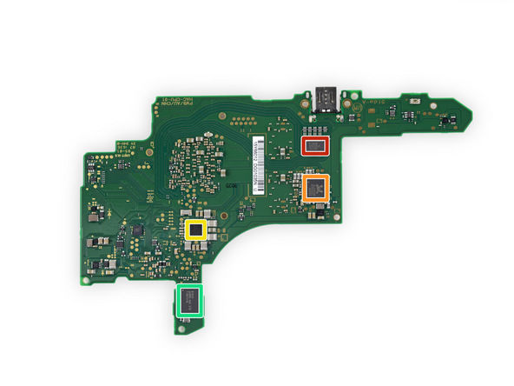

Check the coils, they should have continuity in parallel but not in cross (check each one)

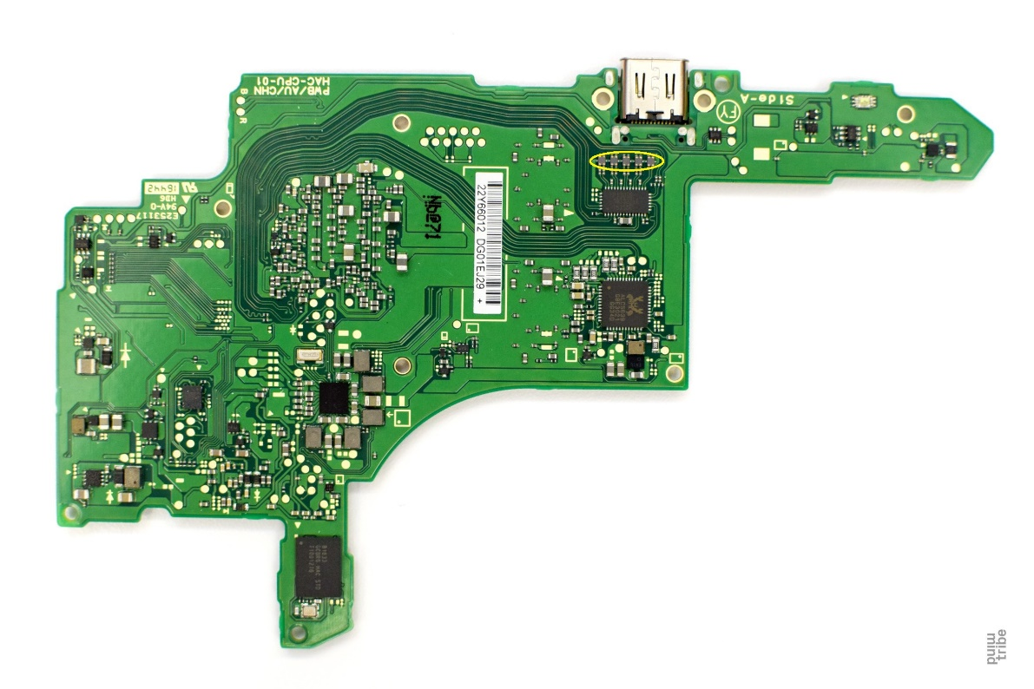

If no image on HDMI docking - Check 3v is getting to the PI3USB.

Now this is important... Does the dock LED go green and the TV attempts to find a signal?

Check around the passives around PI3USB. In particular the ferrite filters. These aren’t the strongest! Bell them with a meter / check impedance / continuity is uniform with all of them

If you have power to the PI3USB, the PI3USB is confirmed good, USB port is soldered good... Caps etc are good around PI3USB...

Those resistors (4 in total) should be good. Guessing they 150R. There is a big (well... 0603 size I think) inductor between pins 4 and 10. Check that. An LC tester would be good for this.

If all turns out to be good, it HAS to be the filters. All it can be.

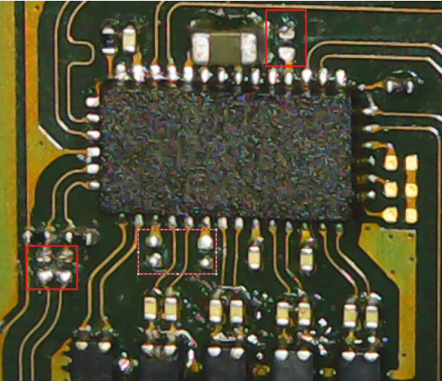

These marked are CAPS – 0201

Red box on left 100nF x 2

The other 100pF

They smooth the signal between the power rails and VBUS and if you get the Switch recognized while docked but then you don’t see image, they are probably the issue

**Nintendo Switch Charging and Power Issues**

Here are some of the most common problems regarding the Nintendo Switch’s charging port and common power issues:

• Nintendo Switch won’t turn on or screen is blank: This is one of the most common issues with the console and can be the result of a couple of different things. The first thing to check is to make sure that the system’s battery is charged by leaving it in the dock for a while. If the console still won’t turn on, it may be frozen and will likely require a hard reset. You can hard reset your Switch by holding the power button down for 15-20 seconds. Once you have held the button down for the allotted time, wait 4-10 seconds for the console to shut down completely and try to restart the device. If it turns back on, that’s great! If not, that’s okay, keep on reading...

**Charging port won’t work:**This issue seems to be caused by many possible conditions and I’m going to try to cover all of them right now.

* Third-party docks: There are reports all over the internet of Nintendo Switches being damaged by the use of third-party docks causing charging ports to fail, or worse, bricking consoles. When in doubt, use official Nintendo accessories to charge your device to prevent any issues. Some 3rd-party docks seem to output the wrong voltage which can cause slow charging or brick the console. Many times a "bricked" console is actually just a console that has a faulty charge controller on the motherboard. This charge controller is a small chip on the motherboard that controls when and how the console charges. If this ic goes bad then the console will not charge even when the charge port is good.
* Wrong charging cables: Nintendo also recently warned against the use of any 3rd-party USB charging cables. They have stated that use of any USB-C cable that isn’t the one included with the console, the pro controller, or the Joycon charging grip can result in permanent damage or a slower charging cycle.
* External battery packs: The rise of portable battery packs has risen sharply in the last few years due to the increasingly heavy power demand of modern electronic devices. Many people have tried to charge the console with portable chargers only to find that the Switch doesn’t charge quickly or breaks completely. If you are insistent on using a battery pack, make sure that you are using a USB-C to USB-C charging cable and that your battery pack outputs the standard voltage and amps (5V-15V and 2.6A output by the official AC adapter) required by Switch chargers.
* Resetting official Nintendo AC adapter: Nintendo recommends the following procedure if your Switch has a blank screen or won’t wake up from sleep mode: replace the Joycons into your Switch, unplug the AC adapter for at least 30 seconds, and plug the USB-C from the AC adapter directly into the Switch. If the screen still is blank, try hard resetting the console again.

If you’re using the provided AC adapter or the official Nintendo Switch dock and they aren’t charging the Switch and none of this works, it’s likely that you will need a new dock, a new adapter, or a repair.

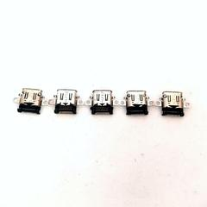

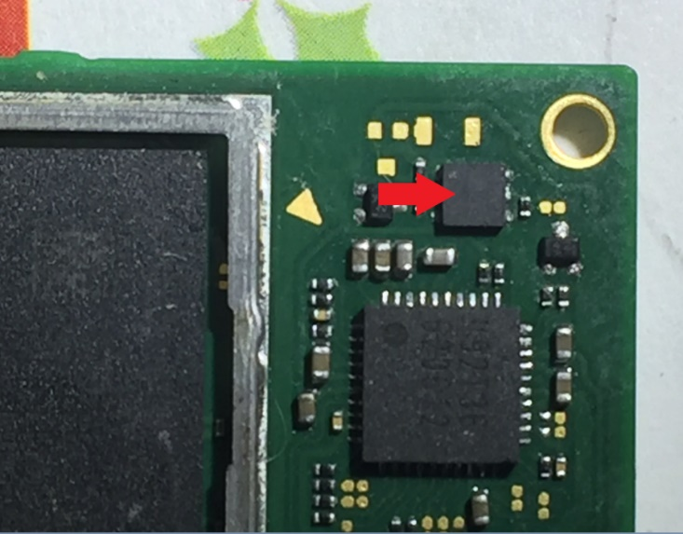

This seems to be a dc~dc converter to turn vbus voltage (20v max) to 5v max on that rail. A buck regulator in other words.

It is going to hi side enable and boost enable. My guess is it senses when vbus is over 4v and kicks in, bringing voltage back down to safe vccin level (max 6v).

**UPDATE:** So it's a dual channel MOSFET. SSM6P49NU

**DIY Charge Port Replacement**

If the charge port on your system is broken, which you can determine by looking inside and finding broken or twisted pins and the console won’t charge or turn on, there is a DIY fix to it. The fix will require soldering skills and a soldering station. If the word ‘soldering’ brings horror to your mind, you should think about sending your console in to have experts fix it for you. For the adventurous few, TronicsFix is going to give you a quick overview in this article. A more in-depth explanation is available on our YouTube channel.

The first thing you’ll need to do is remove the back case of the Switch by taking out all of the screws holding it in place. The Switch’s motherboard must then be removed from the console. The motherboard is the where the charging port is located and, once the board is removed from the system, you can replace the broken charging port. Unfortunately, the charging port is soldered onto the motherboard and must be removed with a hot air soldering tool. Soldering flux must be added to all of the connection points before the broken charging port. Then you must carefully heat up the charging port connection points until you can gently pull up the broken charging port, being careful to not let the motherboard bubble from overheating. Now you can replace the broken port with a new one by slowly heating up the pins on the motherboard. Once the solder on the board is melted, you can quickly attach the new charging port onto the pins. Now that the charge port is installed correctly, you can replace the motherboard into the Nintendo Switch and re-attach the back cover on the console.

This process is very advanced. If you don’t feel comfortable with soldering tools or opening up your Nintendo Switch console, it’s probably easier to let an expert do it for you.

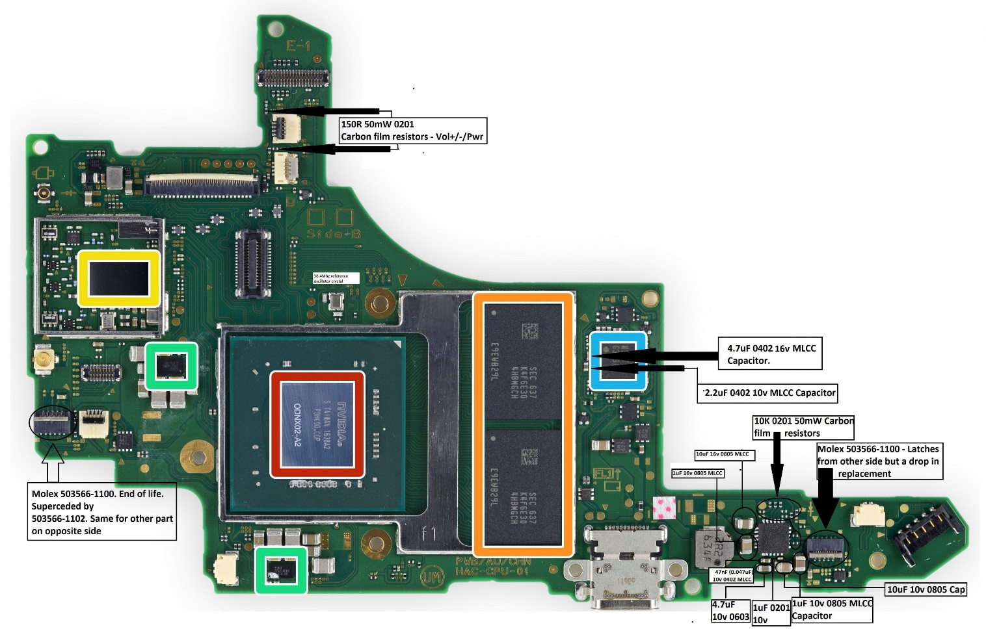

Pinouts

**Cluster A**

|  |  |  |  |  |  |  |
| --- | --- | --- | --- | --- | --- | --- |
| **Pad #** | **Name** | **Type** | **Levels** | **Continuity** | **Frequency** | **Comment** |
| 1 | Batt GND? |  |  |  |  |  |
| 2 | Battery pulse? | Pulse train | 0-3.3V | L-5? |  |  |
| 3 | Battery Vdd |  |  |  |  |  |
| 4 | ?? | Square wave | 0-3.3V |  | 329kHz? (undersampled?) | Square wave when screen on, but looks like vias to Speaker R |
| 5 | ?? | Square wave | 0-3.3V |  | 329kHz? (undersampled?) | Square wave when screen on, but looks like vias to Speaker R |
| 6 | Weak GND? |  |  |  |  |  |
| 7 | SDA | I2C | 0-1.8V |  |  |  |
| 8 | SCL | I2C | 0-1.8V |  |  |  |
| 9 | USB-PWR-WAVE? | Square wave | 0-3.3V | K-4, K-5? | ~11 Hz |  |
| 10 | USB-PWR-WAVE? | Square wave | 0-3.3V | K-4, K-5? | ~11 Hz |  |

**Cluster B**

|  |  |  |  |  |  |  |
| --- | --- | --- | --- | --- | --- | --- |
| **Pad #** | **Name** | **Type** | **Levels** | **Continuity** | **Frequency** | **Comment** |
| 1 |  | DBVDD |  |  |  | from ALC5639 pin 43 |
| 2 | D+ | USB-C |  |  |  | Cluster B - 3 |
| 3 | D- | USB-C |  |  |  | Cluster B - 2 |
| 4 | +3.3V | XRST |  |  |  | from M92T36 pin 4 |
| 5 | +3.3V | VSVR |  |  |  | from M92T36 pin 6 |
| 5(b) | VUSB | VB |  |  |  | from M92T36 pin 9 |
| 6 | GND |  |  |  |  |  |

**Cluster C**

|  |  |  |  |  |  |  |
| --- | --- | --- | --- | --- | --- | --- |
| **Pad #** | **Name** | **Type** | **Levels** | **Continuity** | **Frequency** | **Comment** |
| 1 | ?? |  | 0-1.8V |  |  | No clue. This is definitely important, we just have no idea how. May need to interface with dock for comms. |
| 2 | UART-A TX |  | 0-1.8V |  |  |  |
| 3 | UART-A RX |  | 0-1.8V |  |  |  |
| 4 | ?? |  | 0-1.8V |  |  |  |
| 5 | ?? |  | 0-1.8V |  |  |  |
| 6 | ?? |  | 0-1.8V |  |  |  |
| 7 | ?? |  | 0-1.8V |  |  |  |
| 8 | ?? |  | 0-1.8V |  |  |  |
| 9 | ?? |  | 0-1.8V |  |  |  |
| 10 | ?? |  | 0-1.8V |  |  |  |
| 11 | +1.8V |  | 0-1.8V |  |  |  |

**Cluster D**

|  |  |  |  |  |  |  |
| --- | --- | --- | --- | --- | --- | --- |
| **Pad #** | **Name** | **Type** | **Levels** | **Continuity** | **Frequency** | **Comment** |
| 1 | GND |  |  |  |  |  |
| 4 | Seaker L + |  |  |  |  | Speaker Left + |
| 5 | Seaker L - |  |  |  |  | Speaker Left - |

**Cluster E**

|  |  |  |  |  |  |  |
| --- | --- | --- | --- | --- | --- | --- |
| **Pad #** | **Name** | **Type** | **Levels** | **Continuity** | **Frequency** | **Comment** |
| 1 | Vol (-) |  |  |  |  | Button Vol (-) |
| 10 | Reset |  |  |  |  |  |
| 11 | Vdd Referance |  |  |  |  |  |

**Cluster G**

|  |  |  |  |  |  |  |
| --- | --- | --- | --- | --- | --- | --- |
| **Pad #** | **Name** | **Type** | **Levels** | **Continuity** | **Frequency** | **Comment** |
| 2 | GND |  |  |  |  |  |
| 4 | Vol(+) |  |  |  |  | Button Vol (+) |
| 5 | Li-Ion Batt Vdd Mirror |  |  |  |  | Power Supply |
| 9 | BUTTON\_HOME |  |  |  |  | RCM strap |

**Cluster I**

|  |  |  |  |  |  |  |
| --- | --- | --- | --- | --- | --- | --- |
| **Pad #** | **Name** | **Type** | **Levels** | **Continuity** | **Frequency** | **Comment** |
| 1 | GND |  |  |  |  |  |
| 2 | Screen\_on | On/Off | 0-1.8V |  |  | Screen power state, active high |
| 3 |  | UART | 0-1.8V |  | 1.5MBaud? |  |
| 4 |  | UART | 0-1.8V |  | 1.5MBaud? |  |
| 5 |  | Flow control | 0-1.8V |  |  | Flow control for pad I-4? |
| 6 |  |  | 0-1.8V |  |  | Needs testing with chip/touch screen interface board plugged in |

**Cluster J**

|  |  |  |  |  |  |  |
| --- | --- | --- | --- | --- | --- | --- |
| **Pad #** | **Name** | **Type** | **Levels** | **Continuity** | **Frequency** | **Comment** |
| 1 | ? | Edge | 0-1.8V |  |  | Turns on around same time as pad J-3 |
| 2 | GND |  |  |  |  |  |
| 3 | ? | Edge | 0-1.8V |  |  | Turns on around same time as pad J-1, slightly after |
| 4 | Power button | Pushbutton | 4V-0V |  |  | Active low |
| 5 | ? | Constant? | 0V | Ground?-NT |  |  |
| 6 | ? | Edge | 0-1.8V |  |  | Turns on with pad J-6, ~1s after J-1/J-3 |
| 7 | ? | Edge | 0-1.8V |  |  | Turns on with pad J-5, ~1s after J-1/J-3 |
| 8 | ? | Edge? | 0-1.8V |  |  | Turns on ~1s after J-6/J-7, turns off at unknown point |

**Cluster K**

|  |  |  |  |  |  |  |
| --- | --- | --- | --- | --- | --- | --- |
| **Pad #** | **Name** | **Type** | **Levels** | **Continuity** | **Frequency** | **Comment** |
| 1 | GND |  |  |  |  |  |
| 2 | D- | USB-C |  |  |  | Cluster B - 3 |
| 3 | D+ | USB-C |  |  |  | Cluster B - 2 |
| 4 | USB-PWR-WAVE? | Square wave | 0V-3.3V | A-9, A-10? | ~11 Hz |  |
| 5 | USB-PWR-WAVE? | Square wave | 0V-3.3V | A-9, A-10? | ~11 Hz | Appears to mirror K4. Duty cycle 66.67%. Low on screen lock. Off until first interaction. |
| 6 | USB-C V+ | Supply power |  |  |  | support fast charger : "normal mode = 5V+" "Fast changer = 12V+" |
| 7 | Unknown | Power supply? | ~3V-0V | None known | N/A | 0 when usb-c not plugged in, falls slowly on first interaction if USB-C plugged in. Power draw related? |

**Cluster L**

TODO: Update diagram

|  |  |  |  |  |  |  |
| --- | --- | --- | --- | --- | --- | --- |
| **Pad #** | **Name** | **Type** | **Levels** | **Continuity** | **Frequency** | **Comment** |
| 1 | Li-Ion Batt Vdd Mirror | Power Supply | Std. Li-Ion |  |  |  |
| 2 | GND |  |  |  |  |  |
| 3 | Li-Ion Batt Vdd | Battery Input | Std. Li-Ion |  |  | Should have 3v |
| 4 | Mirrored Ground? |  |  |  |  | Holds steady @ 0, looks like a decoupled isolated ground |
| 5 | Battery pulse? |  |  |  | <1 Hz | Duty cycle ~0% |
| 6 | GND |  |  |  |  |  |
|  |  |  |  |  |  |  |

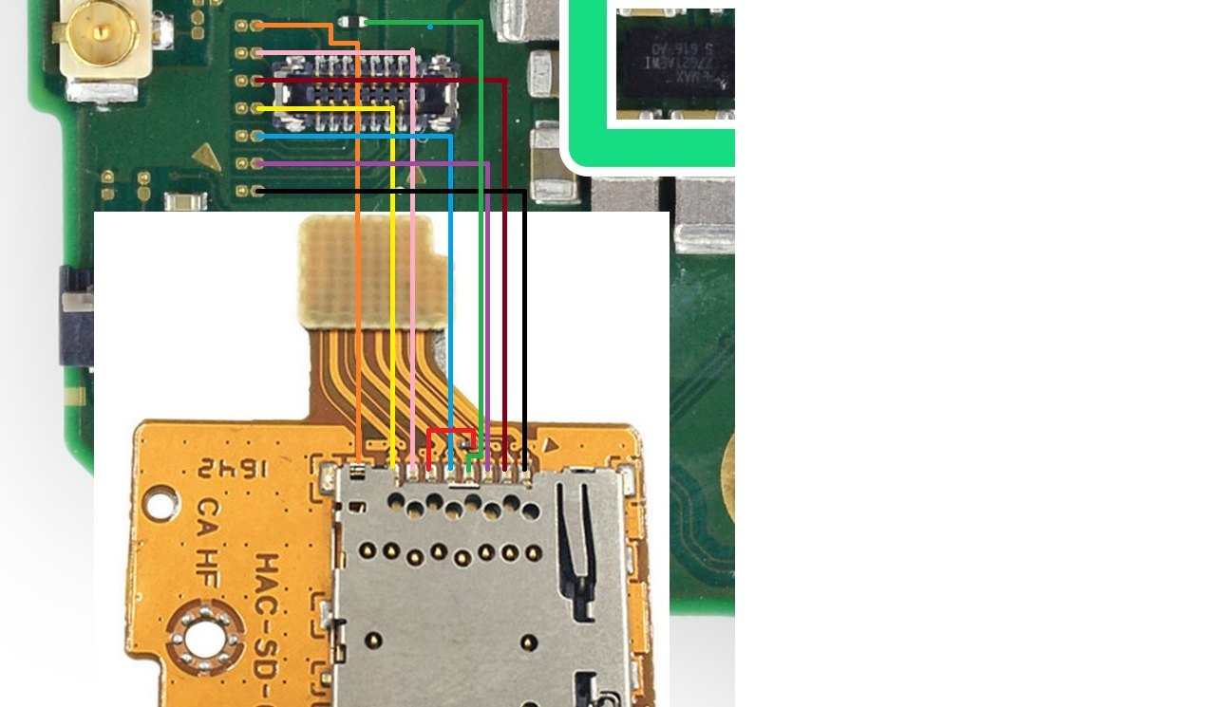

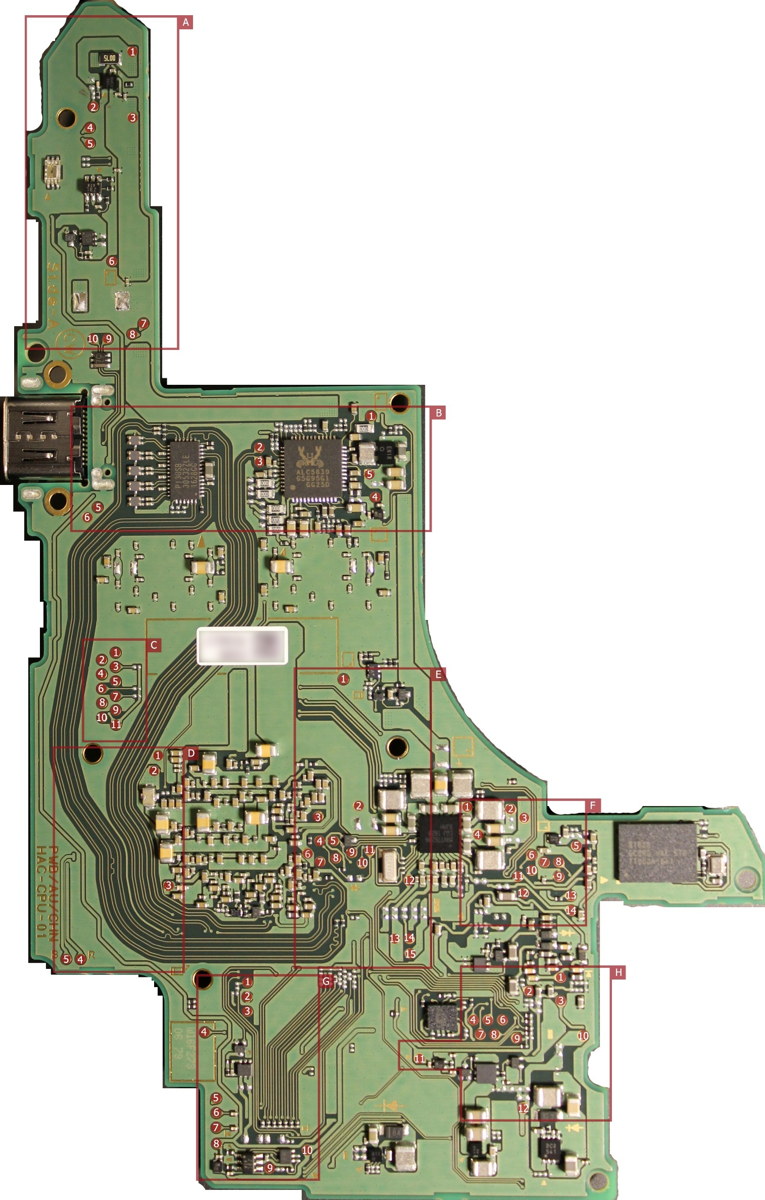

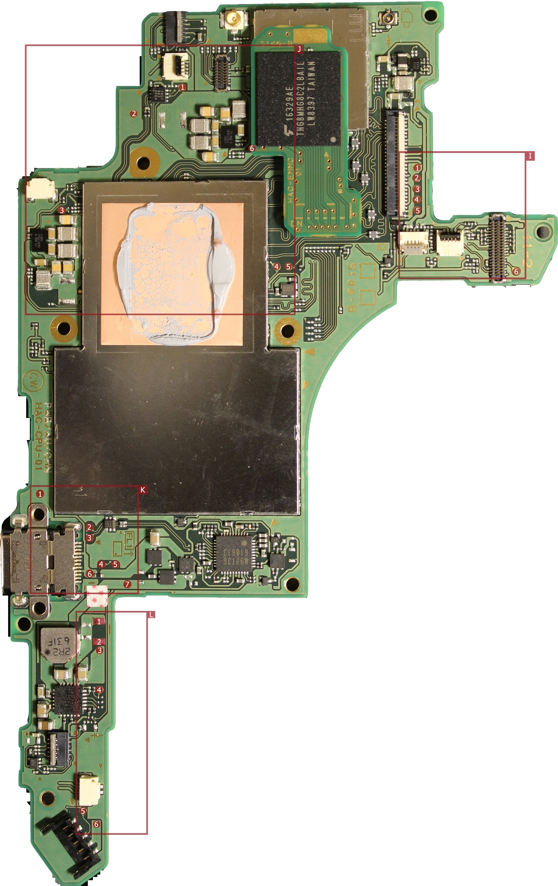

-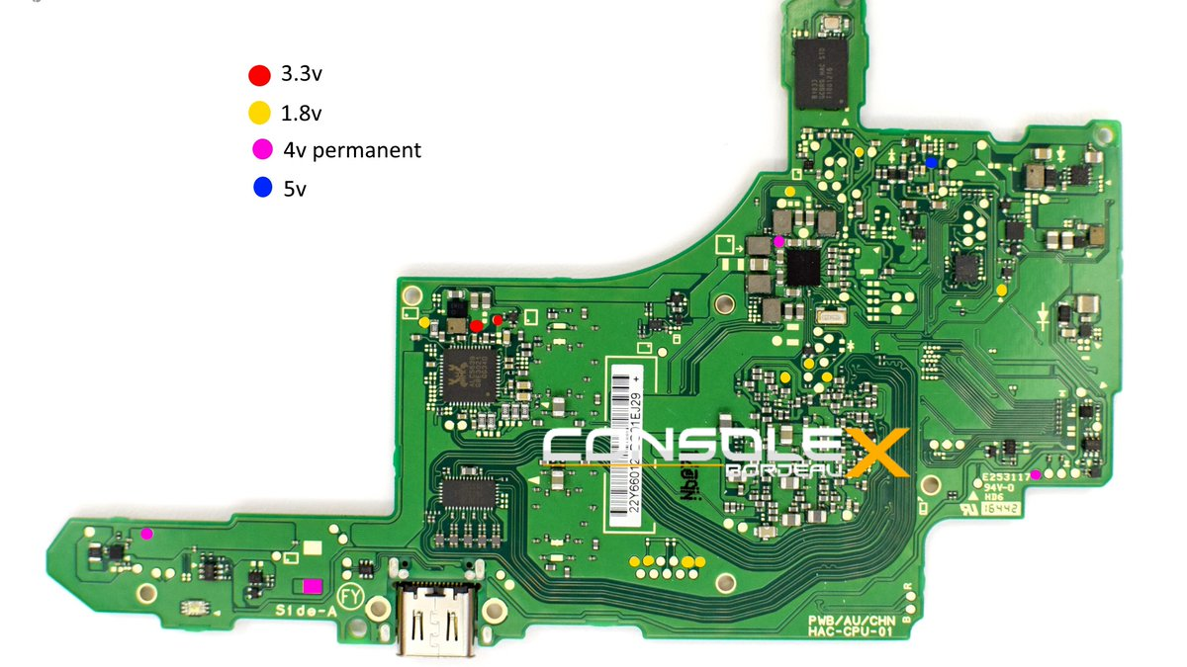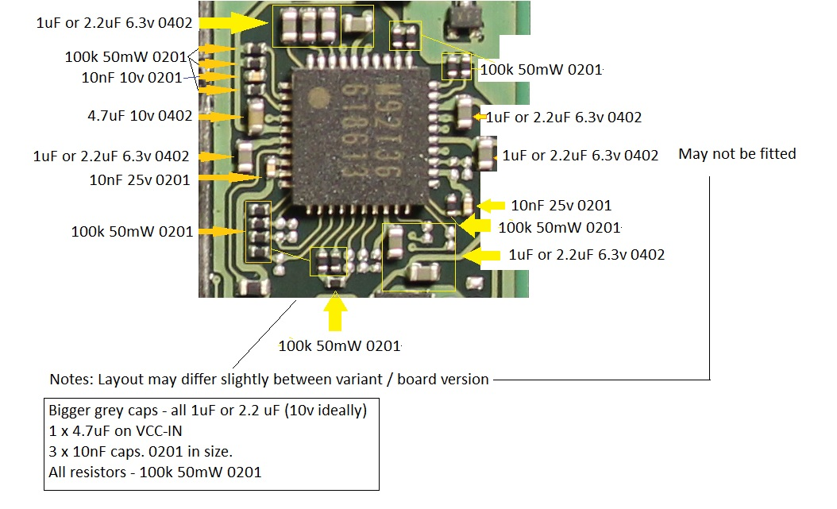

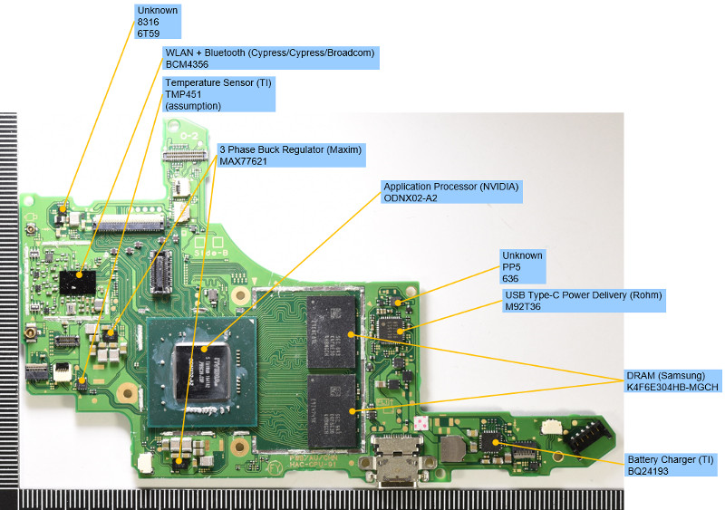

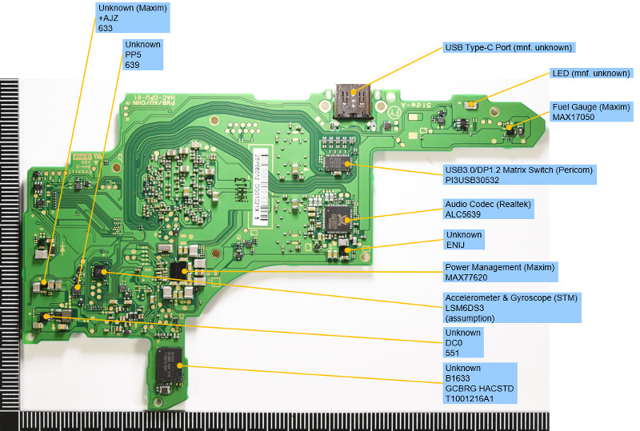

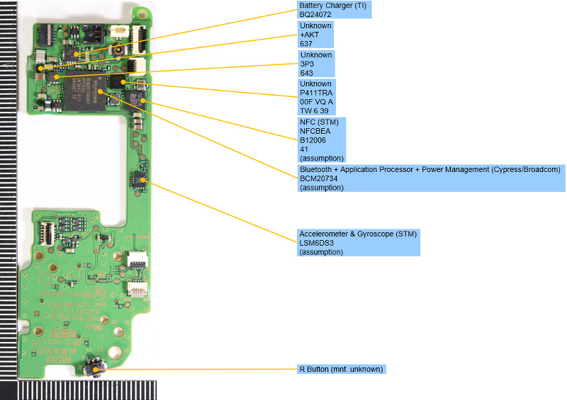

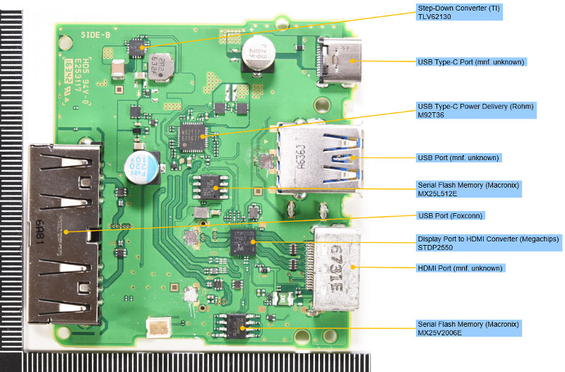

Attention the values in the picture are measured in circuit,

can only be used for comparison of the values on board, so must by removed and tested again.

For example if you replace the 5.6kohm resistor with 10k ,bq 24193 will not charge the battery because the temp set for charghing will bee out of range.

So the 3.8 k and 5.6 k values are critical and its used to set the charghing related to temperature of the battery. (bq 24193 tipical aplication recommend 2.2 k and 6.86k for ts1 and ts2 pins)